

Asset Practice Questions: Science

**1. Answer the question based on the map given below:**

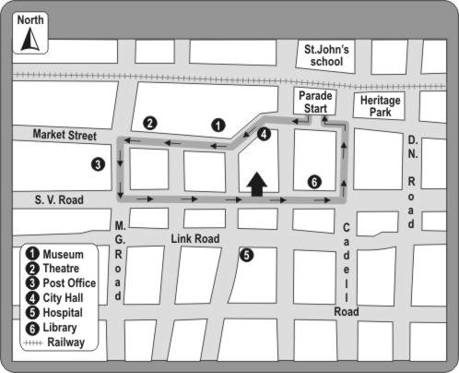

**In the map, the railway line lies to the of St. John's School. Which of these words can fill the blank above correctly?**

**A.** North **B.** South **C.** East **D.** West

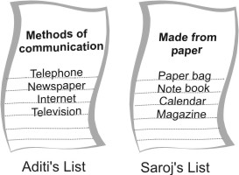**2. Aditi is making a list of methods of communication and Saroj is making a list of things made from paper.**

**Which of the following could be present in both the lists?**

**A.** A stamp

**B.** An inland letter

**C.** A mobile phone

**D.** A cardboard box

**3.**

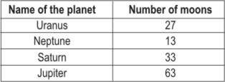

**The bar graph represents the information given in the table above. Choose the letter showing the bar that matches with Uranus.**

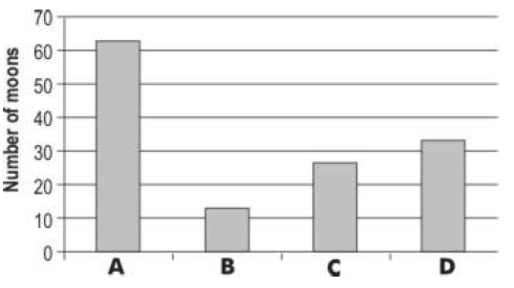

**4. A class had a torn umbrella. Which of the following materials that the teacher gave them, should they use to repair the umbrella?**

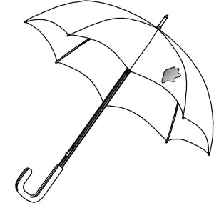

**A.** A piece from an old raincoat.

**B.** A piece of newspaper. **C.** A piece of cardboard.

**D.** A piece of silk cloth.

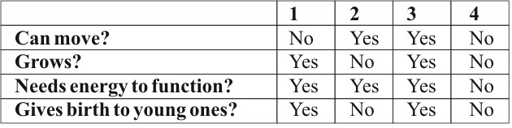**5. The table below shows the properties of four things which we will call 1, 2, 3 and 4. Study the table.**

**Which of them could be LIVING THINGS? A.** 3 and 4

**B.** 1 and 3

**C.** 2 and 3

**D.** 1 and 2

**6. In 1949, Lucky Lady II was the first airplane to go around the world non-stop. The pilots started their flight from a place called Texas in America and flew towards the East. They kept going in the East direction till they reached the same place from where they had started in America. The journey took around 4 days. Answer the following question based on this. People in America would have seen the plane travelling from West to East. In which direction would people in India have seen the plane travelling?**

**A.** Coming from the West and going to the East

**B.** Coming from the East and going to the West

**C.** Coming from the East and going back to the East

**D.** In any direction

**7. Materials have been grouped according to their properties in the table below.**

**Which letter in the table represents a piece of cardboard?**

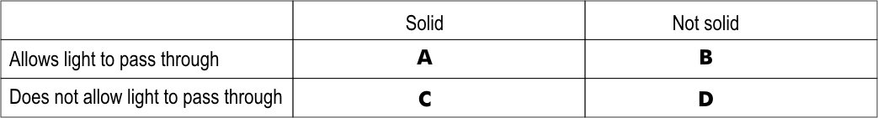

**8. Cooking gas leaks from a cylinder. How will it be known that gas is leaking?**

**A.** From the special smell the gas has.

**B.** From the colour of the gas.

**C.** From the colour of particles in it.

**D.** Drops of liquid will be seen near the gas cylinder.

**9. Why are buses more common than trains in hilly and mountainous areas?**

**A.** Because train engines are not strong enough to climb mountains.

**B.** Because mountainous soil cannot support the weight of the train.

**C.** Because people in the hills are poor, and cannot pay the train fare.

**D.** Because laying railway tracks in mountains is difficult and costly.

**10. Abhay has a mixture of rice, iron nails, wooden pieces and sand. As shown in the figure below, he brings an object close to the mixture.**

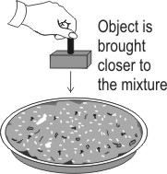

**When he does this, only one of the substances gets separated from the mixture. What object could**

**Abhay be holding?**

**A.** A vacuum cleaner **B.** A strong magnet

**C.** A box with glue

**D.** A wet sponge

**11. How much would I have to walk to reach the restaurant from the tiger enclosure?**

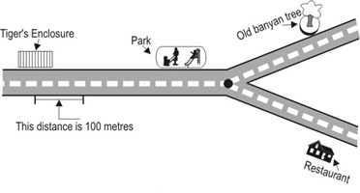

**A.** 200 metres

**B.** 400 metres

**C.** 600 metres

**D.** 800 metres

**12. Jaya takes a glass of water, adds a spoon of sugar and then squeezes the juice of one lemon into it.**

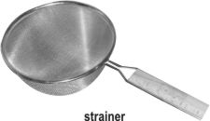**She stirs it well and then pours this through a strainer.**

**What will remain on the strainer? A.** Only water

**B.** Only lemon juice

**C.** Only lemon seeds

**D.** Lemon seeds and sugar